

**Fruit Trees**

**Apple Trees**

**Our apple trees are grafted onto an ‘M27’ rootstock and are ideal for small gardens or for growing in containers, reaching a maximum height of 2 metres (6ft 6in) when mature.**

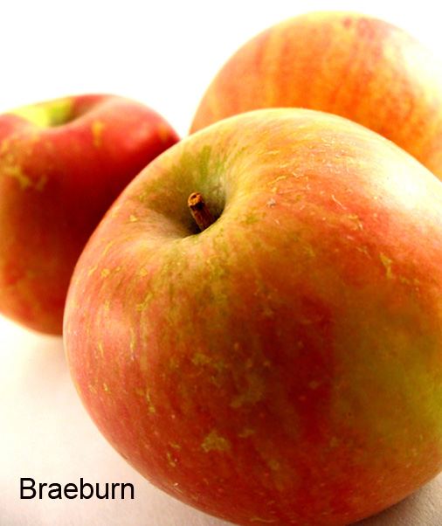**Braeburn**

This well-known late variety produces heavy crops of crisp, juicy fruits with a sweet yet tangy flavour. It does best when grown in a sunny position and is ready to pick from mid-October, but will store until March. It is delicious eaten fresh, but is also good for baking and for making into tarts as it loses very little liquid when cooked. *Pollination group C.*

**Cox **

This classic English apple is known for its outstanding flavour, producing medium sized, crisp and juicy fruits that are ready to pick from early-mid October, but will store until January. It makes an excellent sweet juice when pressed, but requires good soil conditions to thrive. *Self-fertile - Pollination group B*.

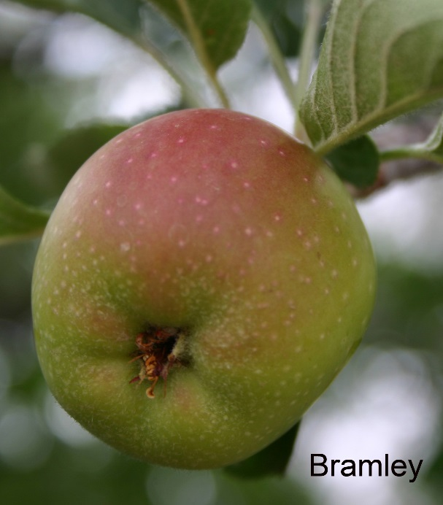 **Gala**

A very popular late apple with a wonderfully sweet flavour and attractive crisp, red flushed fruits. It is a great variety for eating fresh but is also good for pressing and making into juice. Fruits ripen in early October and will keep until early January. RHS Award of Garden Merit. *Pollination group C.*

**Bramley **

This English culinary variety is famous for having a rich, sharp acidity making it perfect for cooking, juicing and making into the most wonderful apple sauces, cooking to fluff. The fruits are large, yellowish-green in colour, flushed with red. Ready to pick in Mid-October it stores until March. RHS Award of Garden Merit. Triploid (will not act as a pollinator). *Pollination group B.*

**Pear Trees**

**Our pears are grafted onto a ‘Quince A’ rootstock and will grow to a maximum height and spread of 2.5-3.5 metres (8-12ft) when mature.**

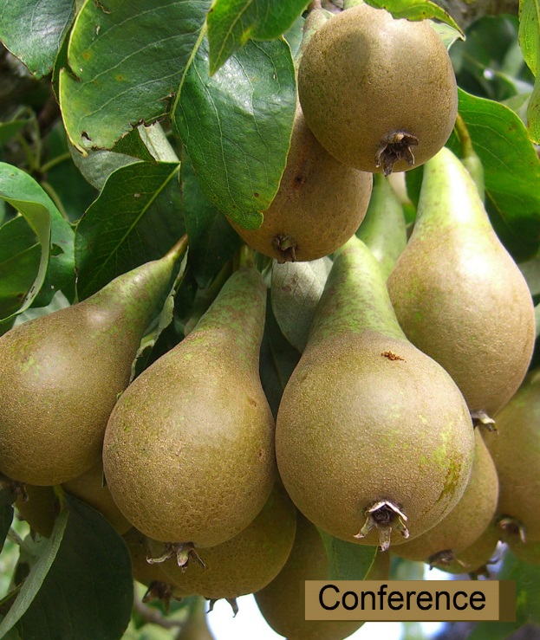**Conference **

The most widely grown pear variety in the U.K. producing reliable crops of long, narrow, firm green fruits with large golden russet patches on its skin. Conference can be picked from late September and will store until late November.   
RHS Award of Garden Merit. Partially self-fertile.   
*Pollination Group C.*

**Onward **

Produces high quality sweet flavoured, medium to large fruits with a delicious, flesh that melts in the mouth. A good and reliable cropper, the fruits are yellow in colour, flushed orange with occasional russeting. Crops mid-September and will store until early October. RHS Award of Garden Merit. *Pollination Group D.*

**Cherry Trees**

**Our dessert cherries are grown on a ‘Gisela 5’ rootstock making a small tree that will reach a maximum height and spread of 1.8-3 metres (6-10ft). The Morello (acid) cherry is supplied on a ‘Colt’ rootstock and can grow up to 4.5-6 metres (15-20ft) when mature, but its height can be restricted with regular pruning.**

**Stella**

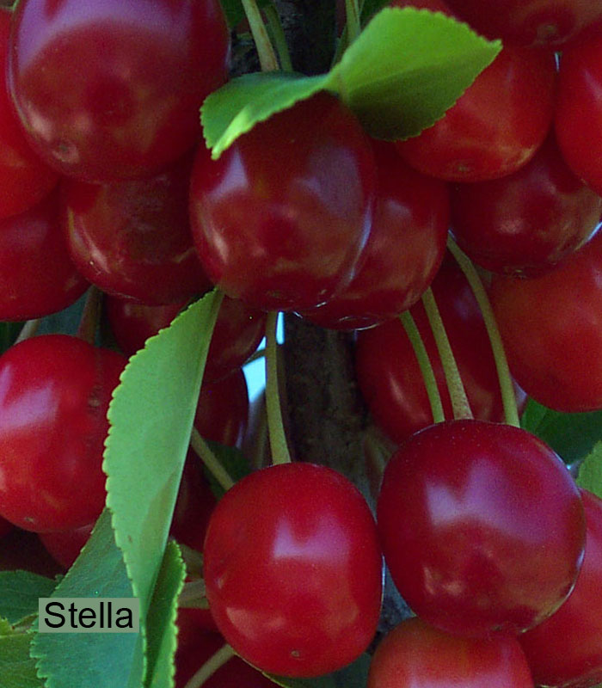Produces heavy crops of dark red cherries during early July which have an excellent flavour. The variety is hardy and reliable and is less prone to bacterial canker than many other varieties. RHS Award of Garden Merit. *Self-fertile.*

**Sunburst**

A relatively modern dessert variety producing large dark red, almost black cherries with a soft flesh and wonderfully sweet flavour. A reliable and heavy cropping variety it ripens around mid-July. *Self-fertile.*

**Morello **The most common acid or sour-cherry variety, it is excellent for cooking, when its rich, strong cherry flavour is at its best, making it ideal for pies, jams and preserves. Easy to grow and heavy cropping, it ripens in late July. RHS Award of Garden Merit. *Self-fertile.*

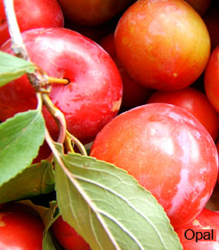**Plum, Gage & Damson Trees**

**Our plum and gage trees are supplied on a ‘Pixie’ rootstock and will reach a maximum height and spread of 1.8-3 metres (6-10ft). Damson trees are on a ‘St. Julian A’ rootstock and will grow to a height and spread of around 3.5-4 metres (12-15ft).**

**Opal (Plum)**

Produces medium-sized, gage-like fruits that are red in colour with an excellent flavour. A good dessert variety, but also makes a delicious jam. Ripens between late July and early August. RHS Award of Garden Merit.   
*Self-fertile Pollination group B.*

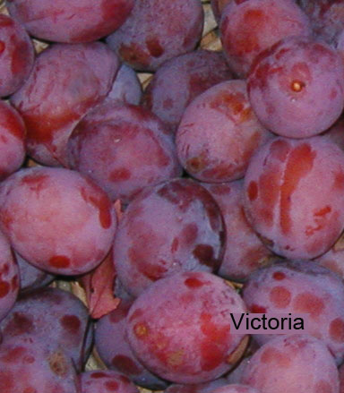 **Jubilee (Plum)**

This dessert/culinary variety produces fruits that have a similar appearance and flavour to those of Victoria, but are much larger is size, with a stone that separates easily from the flesh. Ripens mid-late August.   
*Self-fertile Pollination group B.*

**Victoria (Plum) **

The most widely grown plum variety in the U.K. it is suitable for both dessert and culinary purposes, producing heavy crops of large, pale red fruits that are wonderfully juicy. Has good frost resistance. Ripens between late August and early September. RHS Award of Garden Merit.   
Self-fertile. Pollination group B.

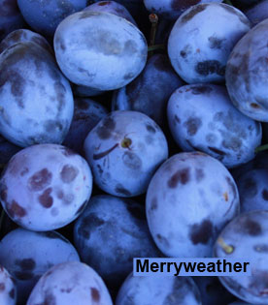**Old English Greengage (Gage) **

Grown for its exceptional flavour, it produces yellowish-green fruits that are very juicy and are delicious eaten fresh, but are also excellent for cooking and preserves. Ripens late August.  
*Pollination group B.*

**Merryweather (Damson) **

An excellent flavoured damson producing large, juicy fruits that are slightly acidic and are ideal for both eating fresh straight from the tree or used for culinary purposes. Ripens September.   
*Self-fertile* Pollination group B.

**Peach & Almond Trees**

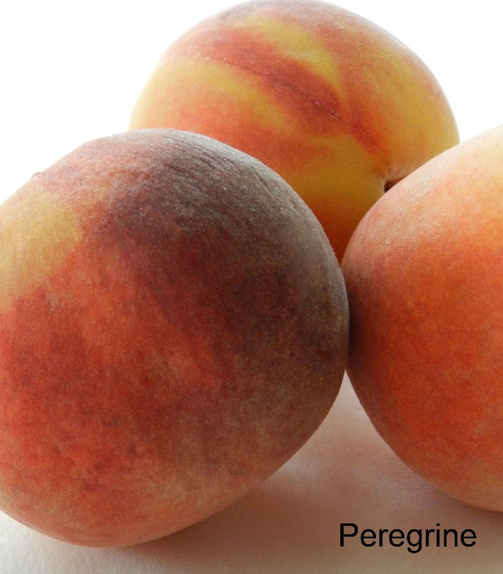**Our peach and almond trees are grafted on a ‘St. Julian A’ rootstock and will grow to a height and spread of around 3.5-4 metres (12-15ft).**

**Peregrine (Peach) **

An excellent flavoured, white fleshed peach which was bred in the U.K. and produces stunning dark pink blossom in spring followed by delicious orange/red fruits in mid-August. RHS Award of Garden Merit. *Self-fertile.*

**Ingrid (Sweet Almond)**

Produces attractive pale pink blossom in spring and good flavoured sweet almonds in late August. It is a reliable variety in the U.K. given a sunny, sheltered position and shows some resistance to peach leaf curl. *Self-fertile.*

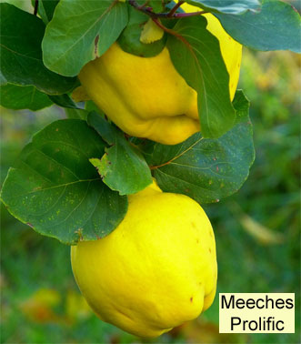 **Quince Trees**

**Quince trees are grafted on a ‘St Julian A’ rootstock, growing to a height and spread of around 3.5-4 metres (12-15ft).**

**Meeches Prolific**

This popular quince variety, ripens in October and produces golden yellow, pear shaped fruits, with a fragrant scent and can be used to make a delicious quince jelly, or added to apples in pies. It is also grown for its pale pink blossom and ornamental value. *Self-fertile*.

**Soft Fruits**

**Blueberries**

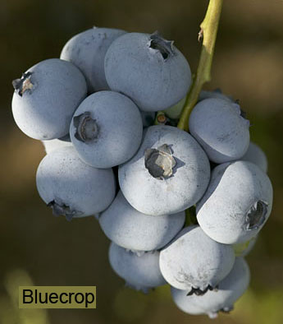**Blueberries require an acid soil with a pH of between 4-5.5 to thrive. They can also be grown in containers using an ericaceous compost mixed with grit.**

**Bluecrop**

An excellent mid-season blueberry considered to be one of the most reliable varieties, producing heavy crops of good flavoured fruit in late July/August. It is fully hardy, looks attractive throughout the year with white flowers in spring, blueberries in summer, colourful foliage in the autumn followed by deep red stems during winter. It has an upright growing habit, is suitable for growing in containers and although it is partially self-fertile, produces its heaviest crops when grown with another blueberry variety. Eventual height if grown in ideal conditions in open ground 1.5m (5ft). Plants grown in containers will reach approximately 1m (40in).

**Goldtraube**

An early fruiting variety that crops heavily and dependably from early July through to August. It produces delicate clusters of pinkish-white, bell shaped flowers in spring followed by large, light blue berries that are of a very good flavour. In autumn its foliage puts on a colourful display. Requires a pollinator.  
Eventual height if grown in ideal conditions in open ground 1.5m (5ft). Plants grown in containers will reach approximately 1m (40in).

**Northland**

A slightly more compact early/mid-season variety that ripens between mid-July and August. Berries are medium sized, sweet, and dark blue in colour and are excellent eaten straight from the bush as well as being good for baking and freezing. Bell shaped white flowers, tinged pink are produced in spring and in autumn its foliage turns stunning shades of yellow and orange. Eventual height if grown in ideal conditions in open ground 1.25 (4ft). Plants grown in containers will reach approximately 90cm (35in). Requires a pollinator.

**Blackberries and Blackberry Hybrids**

**These cane fruits can often provide decent crops for up to twenty years and prefer a moisture-retentive, but free-draining soil in a sunny sheltered position, but will also tolerate light shade. They are best grown and trained onto a sturdy support system such as a wall or fence, or on a free-standing post and wire system, with horizontal wires spaced 45cm (18in) apart. They fruit on year old wood produced the previous season.**

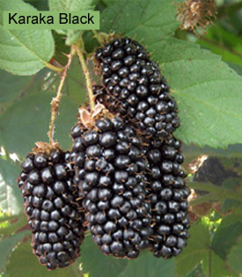**Blackberry ‘Karaka Black’**

This compact blackberry variety is ideal for smaller gardens or for growing in large containers.  It has a long cropping period, from early July through to early September and produces extremely large, shiny, conical shaped fruits that have a good sweet blackberry flavour. It is also excellent for freezing. Requires 90-120cm (3-4ft) of wall space.

**Blackberry ‘Black Pearl’**

This early blackberry variety yields firm, conical shaped fruit of an excellent flavour during July. The plant has a trailing habit and although the very young canes can be bristly they become thornless as they mature. Requires 4.5m (15ft) of wall space.

**Loganberry **

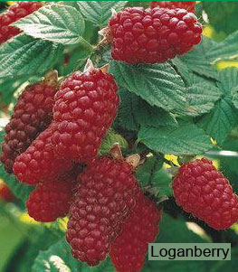Loganberries are a cross between a raspberry and a blackberry, with slightly longer, juicier fruits that are dark red in colour when ripe, with a sharper flavour. High in vitamin C they have good disease resistance, are easy to grow and ripen over a long period of time, starting from the middle of July though to September. Loganberries can be eaten fresh or used as an alternative to blackberries and raspberries in recipes, but are most commonly used in jams, pies and crumbles. Requires 2.4m (8ft) of wall space.

**Tayberry **

The Tayberry is another hybrid cross between a raspberry and blackberry, with dark reddish-purple fruits that ripen from July through to mid-August and are larger, sweeter and mellower in flavour than those of the loganberry. Suitable for eating fresh they are excellent used in jams, jellies and desserts. Requires 2.4m (8ft) of wall space.

**Gooseberries**

**Gooseberries are easy to grow and are able to cope with a wide range of soil conditions. They should be planted 1.2-1.5m (4-5ft) apart and grow best in a sunny position, but will tolerate partial shade.**

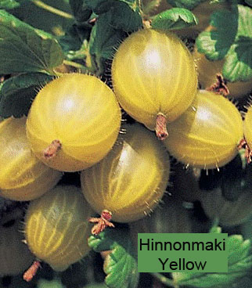**Captivator**An excellent dessert variety which has a vigorous spreading habit and carries medium-large, sweet, burgundy coloured fruits during late July. It is relatively thornless, very cold hardy and shows good resistance to powdery mildew.

**Hinnonmaki Red**

A great dessert/culinary gooseberry that produces heavy crops of medium to large, sweet yet tangy red fruits in mid-July with an exquisite flavour. It has a semi upright growing habit and is resistant to American gooseberry mildew.

**Hinnonmaki Yellow**

A very hardy dessert gooseberry that is so sweet it can be eaten straight from the bush. ‘Hinnonmaki Yellow’ produces extremely heavy crops of medium sized greenish-yellow berries that have a slight hint of apricot in their flavour. It has a lax spreading habit, so may need a little support when heavily laden and shows excellent disease and mildew resistance.

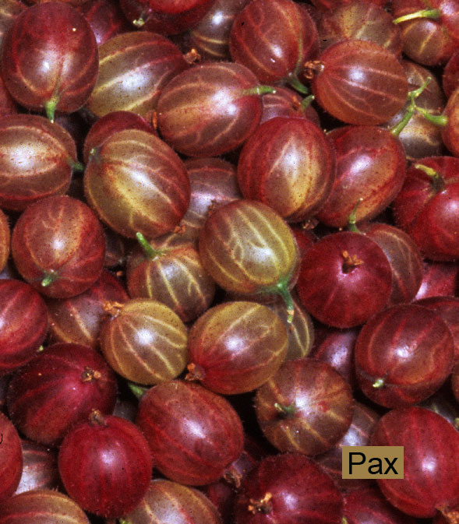**Invicta **

This outstanding culinary variety is deservedly popular producing exceptionally heavy crops of large, smooth skinned, pale green berries in late July that are delicious in pies, crumbles and preserves and retain their shape when cooked. It is very vigorous, has a spreading habit and shows excellent resistance to mildew. RHS Award of Garden Merit.

**Pax **

Produces very heavy crops of large, slightly bristly, dark red fruits in mid-July on virtually spine-free canes. ‘Pax’ shows some resistance to powdery mildew and leaf spot, has an upright growing habit and is suitable for dessert purposes.

**Raspberries**

**There are two different forms of raspberry, ‘Floricanes’ and ‘Primocanes’, known more commonly as summer and autumn fruiting varieties. Summer fruiting raspberries (Floricanes) produce fruit on year old wood that grew in the previous season. These tend to be much taller and require a post and wire system for support. Autumn fruiting raspberries (Primocanes) fruit on new wood produced in the current season and therefore tend to have a more compact growing habit, requiring little if any support when grown in a sheltered position. Raspberry canes should be planted shallowly, 40-60cm (16-24in) apart in rows, allowing 1.5-1.8m (5-6ft) between rows.**

**Summer Fruiting Raspberries (Floricanes)**

**Malling Minerva **

Considered one of the best early summer fruiting varieties available, ‘Malling Minerva’ produces superb flavoured, medium to large conical shaped fruits, on compact, spine free canes from early June for up to six weeks. It has very good disease and virus resistance and the fruits freeze well.

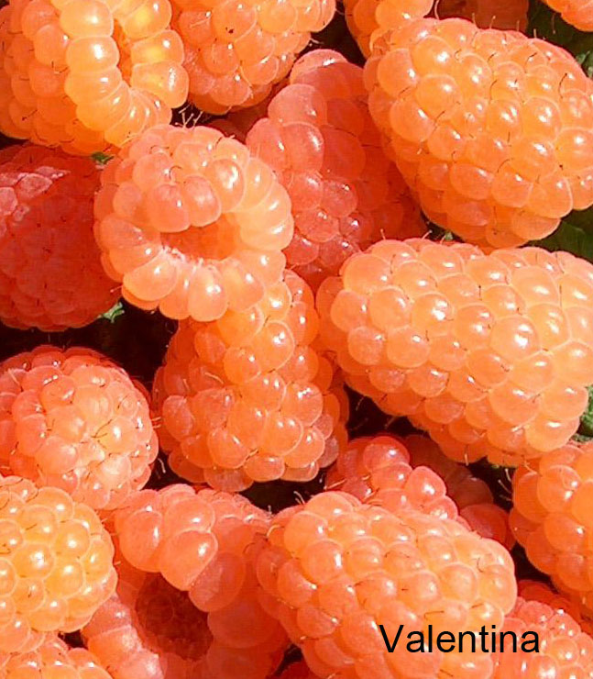**Glen Moy **

A popular early fruiting raspberry that crops heavily and yields firm, medium sized fruits of a very good flavour and quality from mid-June through to July on virtually spine-free canes. It requires a well-drained soil and shows good resistance to aphid colonisation the main carriers of virus. RHS Award of Garden Merit.

**Valentina **

An attractive and unusual apricot-pink coloured raspberry that produces exceptionally heavy crops of medium to large berries from mid-June through to July, with an excellent flavour. The canes are tall, carry few spines and have an upright growing habit. ‘Valentina’ has extremely good pest and disease resistance making it an ideal choice for organic growers.

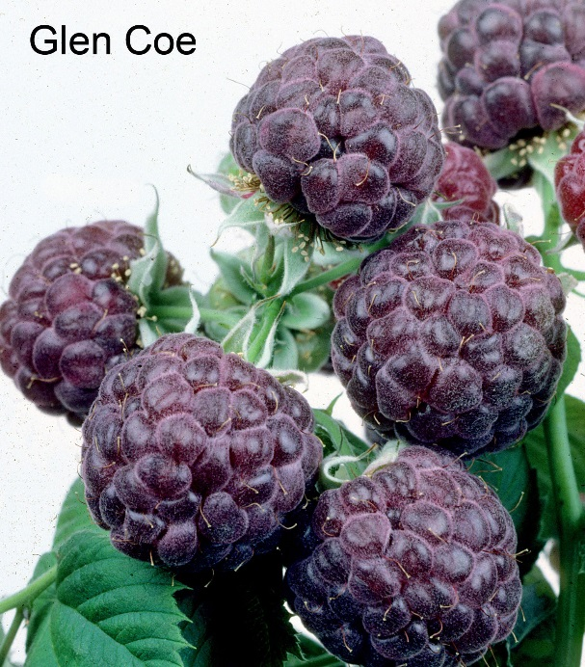**Glen Ample** 

A mid-season variety that produces outstanding yields of large, firm, deep red berries of an excellent flavour from late June through to the end of July. Canes are upright, vigorous and spine free. RHS Award of Garden Merit.

**Glen Coe** 

This specialist mid-season variety is the result of a cross between a black and a red raspberry and produces good crops of deep purple fruits from mid-June until late August. It has an exceptional flavour and is delicious eaten fresh but also makes superb jams, sauces and wine. ‘Glen Coe’s’ canes are spine free and shows good disease resistance.

**Autumn Fruiting Raspberries** (**Primocanes**)

**Autumn Bliss **

This well-known and popular autumn variety produces heavy crops of large, firm, deep red berries with a very good flavour from August through to first frosts. The short, erect, spiny canes of this variety need only the minimum of support if grown in a sheltered position. Shows good resistance to raspberry root rot disease. RHS Award of Garden Merit.

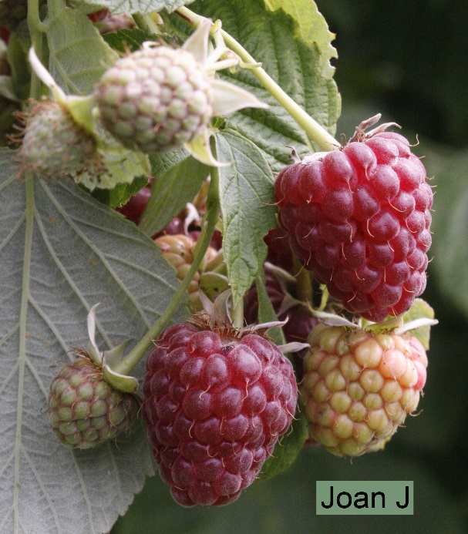**Joan J**

This modern variety is known for its huge berry size and superb flavour and is excellent for eating fresh, but also freezes well. Cropping commences from late July/early August for period of approximately seven weeks. 'Joan J' is spine-free, sturdy and self-supporting. RHS Award of Garden Merit.

**Allgold **

A yellow sport of 'Autumn Bliss' this superb variety produces heavy crops of golden yellow fruits, on spiny canes, from August through to mid-October. The berries are soft and have exquisite sweet flavour, often considered superior to its red relation. Because of its compact habit it requires very little support. RHS Award of Garden Merit.

**Currants**

**Blackcurrants and redcurrants will grow well in a wide range of soil conditions and prefer full sun, but will also tolerate light shade. They should be planted 1.2-1.5m (4-5ft) apart, or can be grown in 45-50cm (18-20in) containers, using a John Innes no.3.**

**Blackcurrants**

**Ben Connan **

A heavy cropping yet compact blackcurrant variety producing exceptionally large, glossy black fruits with an excellent rich blackcurrant flavour from mid-July. It shows very good resistance to mildew and is frost tolerant. RHS Award of Garden Merit.

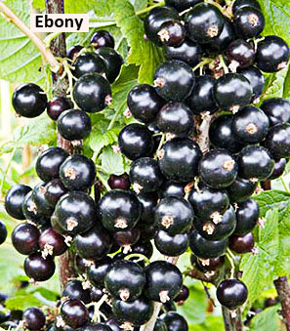**Ben Sarek** 

Forms a neat, compact bush rarely growing beyond one metre in height. The berries are large and have a good flavour, perfect for pies and jam making. The variety is frost resistant and shows good resistance to mildew.

**Ebony **

This modern blackcurrant is a genuine dessert variety, producing very early crops of sweet, superbly flavoured blackcurrants from early July. Cropping heavily the fruits are large and firm with a delicate flavour. The bush has an open, slightly spreading habit and is moderately vigorous.

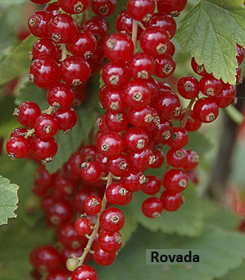**Redcurrants**

**Rovada**Produces exceptionally heavy crops of superb quality, large redcurrants that are formed on long trusses making them easy to pick. Harvested from late July ‘Rovada’ shows good disease resistance and is also suitable for growing in containers.

**Rhubarb**

**Rhubarb should be planted 90cm (3ft) apart. You should not pick any stems within the first year of planting to enable it to establish.**

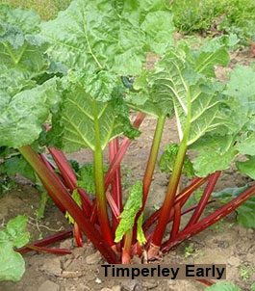**Timperley Early**

The earliest and best all round variety for both forcing and outdoor cultivation. If forced ‘Timperley Early’ will provide large, red-based pink stems, passing to green, with a very good flavour from February, but if left to grow naturally can be harvested from early March to late August. RHS Award of Garden Merit.

**Victoria **

This popular late variety, reputedly named after Queen Victoria produces heavy crops of greenish–pink stems that are a deep raspberry colour at their base and have a perfect balance of sweetness and acidity. Stems can be picked from April to August, but can be harvested earlier if forced.

**Stockbridge Arrow **

This modern Yorkshire bred variety, is one of the best quality rhubarbs around and is said to have been given its name on account of the shape of its leaves, which are shaped like an arrow. It produces long attractive dark red stems with a wonderful delicate flavour that can be pulled from April through to August, but is also suitable for forcing to bring on an earlier crop.

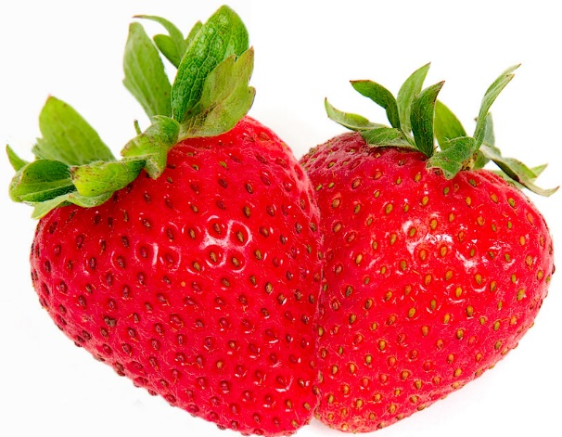**Strawberries**

**Strawberries will grow on a wide range of soils but will benefit from being grown in raised beds on poor or heavy soils. Best planted in a sheltered position they will normally crop for three to four years before needing to be replaced. They are also ideal for growing in containers where a good quality multipurpose, or a John Innes No.2. compost should be used. Strawberry plants should be spaced 30-40cm (12-16in) apart with a 75-90cm (30-36in) gap between rows.**

**To extend the strawberry season a combination of early fruiting (early/mid-June to early July), mid (late June to mid-July) and late summer (throughout July) varieties should be grown along with some ever-bearers which crop from July through to first frosts, with the odd berry in early summer.**

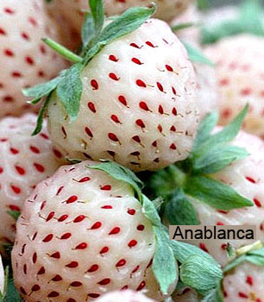**Christine (Early-summer)**

This excellent early summer strawberry variety bears large, sweet red fruits with a wonderful flavour. It shows good resistance to powdery mildew, but as it flowers early may require fleece protection. Normally cropping from early June when grown outside, it will fruit even earlier if grown undercover in a [cloche](http://kenmuirltd.createsend1.com/t/r-l-ptlkuut-l-d/), greenhouse or polytunnel.

**Anablanca (Mid-summer)**

These rare white strawberries are closely related to the Pineberry and are delicious eaten fresh but are also good for jam making. The berries start off green in colour and turn paler as they ripen to produce sweet and juicy fruit with an aromatic flavour reminiscent of pineapple. The flesh is studded with attractive coloured seeds.

**Cambridge Favourite (Mid-summer) **

This much loved traditional strawberry variety produces heavy crops of medium sized, sweet, juicy red fruits with a very good flavour. It has good disease resistance and can be relied on to do well under a wide range of growing conditions. RHS Award of Garden Merit.

**Frau Mieze Schindler (Mid-summer)**

Still the most popular strawberry variety grown across much of Europe it can only be described as one of the best tasting strawberries ever bred. This claim is backed up by scientific studies which have proven that ‘Frau Mieze Schindler’ has a high concentration of the flavour component that gives the strawberry its exquisite sweet flavour. The size of plant and yields, although modest compared to modern varieties, are vastly superior to the alpine strawberry and disease resistance is good. Fruiting from mid-June to mid-July this delicious strawberry benefits from being grown alongside another variety, we recommend Cambridge Favourite at a ratio of 10:1.

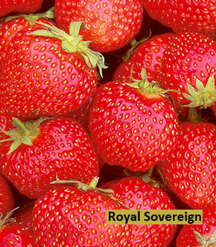**Elsanta (Mid-summer)**

One of the most widely grown varieties in the U.K. and favoured by commercial growers, ‘Elsanta’ produces heavy crops of large, sweet red fruits with a very good flavour.

**Royal Sovereign (Mid-summer) **

This traditional variety has stood the test of time and produces large, sugar sweet, bright scarlet berries, that despite producing a slightly smaller crop than many modern varieties, more than makes up for in flavour which can only be described as sublime.

**Sonata (Mid-summer)**

Produces large, top quality, conical shaped fruits with an attractive bright red, glossy appearance. It copes well in both hot and wet weather conditions, crops heavily and has an excellent flavour.

**Fenella (Late-summer) **

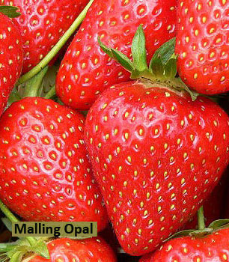This modern late variety bears heavy crops of delicious, large fruits that have a superb flavour and stand up well to adverse weather conditions. The plants are hardy, show good disease resistance and have a strong upright growing habit.

**Flamenco (Everbearer) **

A perpetual variety combing both heavy crops with exceptional fruit quality and flavour. The berries are medium-large in size, have a glossy orange-red colouring and an excellent, sweet flavour. Harvesting commences in July, with the heaviest crops being picked during September.

**Malling Opal (Everbearer)** 

An early season everbearer producing heavy crops of large, attractive, conical shaped berries with a good sweet flavour and juicy texture. Fruiting heavily during July and August it will continue yielding lighter crops until first frosts.